

Submitted By:
Noor-Ul-Ain – 2025-CE-83
Assignment:
Lab No. 7
Submitted To:
Professor Mehmood

For the fulfillment of,
Circuit Analysis Lab
Department of Computer Engineering
University of Engineering and Technology, Lahore

Experiment
This experiment studies how an operational amplifier (IC 741) amplifies input signals in two modes:
- Inverting Amplifier → Output is amplified but 180° out of phase
- Non-Inverting Amplifier → Output is amplified and in phase
The relationship between input and output voltage depends on resistor values (gain).

Steps / Procedure

Inverting Amplifier
- Connect the circuit on breadboard using IC 741.
- Apply AC input signal to pin 2 (inverting terminal) through resistor.
- Ground pin 3 (non-inverting terminal).
- Connect feedback resistor between output (pin 6) and pin 2.
- Provide ±VCC supply (pin 7 = +V, pin 4 = –V).
- Connect oscilloscope:
  - CH A → Input
  - CH B → Output
- Observe waveform → output is inverted.

connections:
- Input signal → Pin 2 (inverting input) via resistor (R1)
- Feedback resistor (Rf) → between Pin 6 (output) and Pin 2
- Pin 3 (non-inverting) → Ground

Formula (important for viva):
Av=−Rf / Rin

Example:
- R1 = 1kΩ
- Rf = 2kΩ
👉 Gain = -2

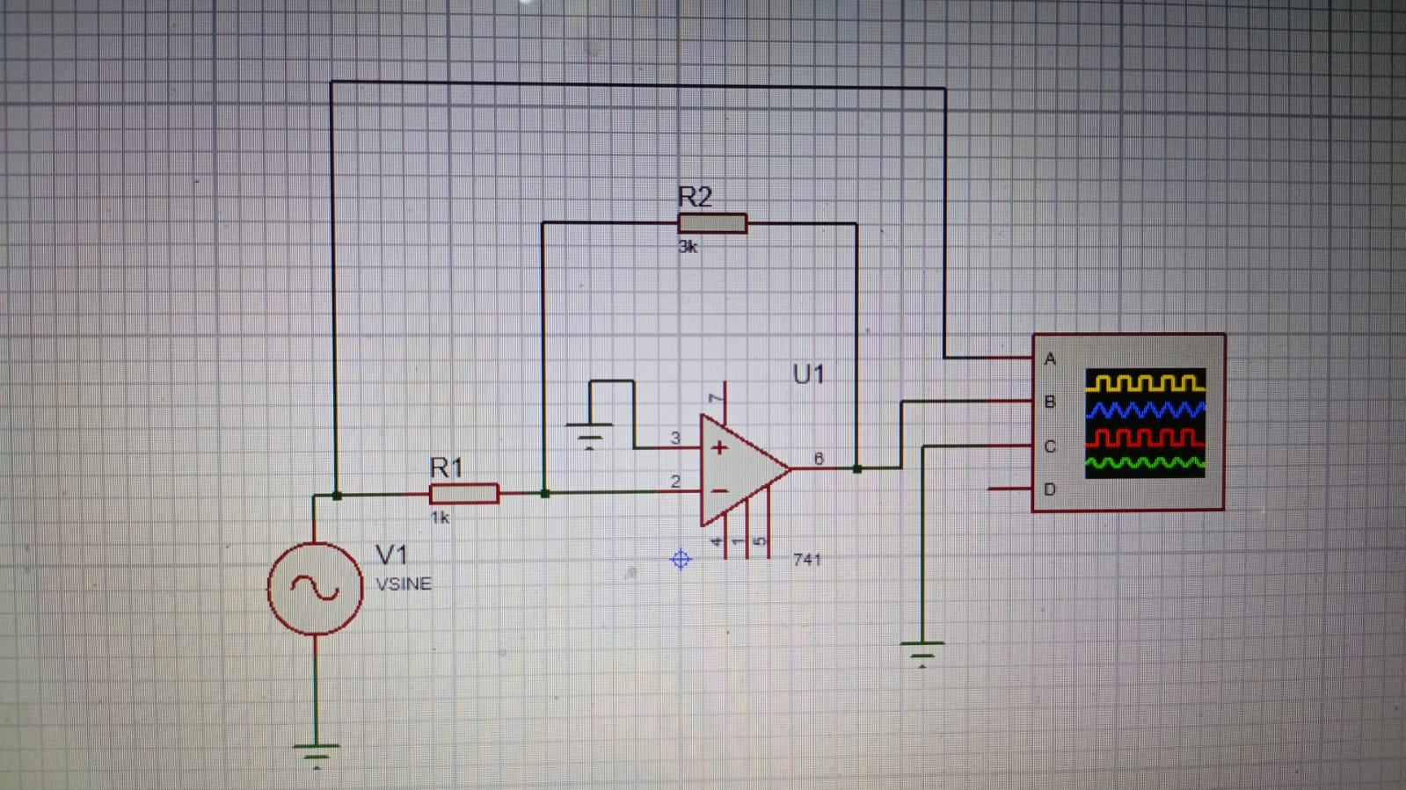

Non-Inverting Amplifier
- Connect circuit using IC 741.
- Apply input signal to pin 3 (non-inverting terminal).
- Connect resistor network between pin 2 and output.
- Provide dual power supply (±VCC).
- Connect oscilloscope same way.
- Observe waveform → output is same phase.

Connections:
- Input → Pin 3 (non-inverting input)
- Pin 2 → connected to:
  - Ground via R1
  - Output via Rf

Formula:
Av=1+Rf /R1

Example:
- R1 = 1kΩ
- Rf = 2kΩ
👉 Gain = 3

